Compound Noun

🔹 What is Compound Noun
# Source: AI Source: Provided by: [Data Path: Persons Table -> ID Column: 1, Name_En Column: Motasem Essam] -> From: [Chatgpt (GPT-4-turbo)] on [7/26/2025]
A compound noun is a noun made up of two or more words that function as a single noun.
✨ The combined words create a new meaning different from the individual parts.

✅ Definition:
# Source: AI Source: Provided by: [Data Path: Persons Table -> ID Column: 1, Name_En Column: Motasem Essam] -> From: [Chatgpt (GPT-4-turbo)] on [7/26/2025]
A compound noun joins two or more words (usually nouns, adjectives, or verbs) to form one noun with a specific meaning.

🧱 Forms of Compound Nouns:
# Source: AI Source: Provided by: [Data Path: Persons Table -> ID Column: 1, Name_En Column: Motasem Essam] -> From: [Chatgpt (GPT-4-turbo)] on [7/26/2025]
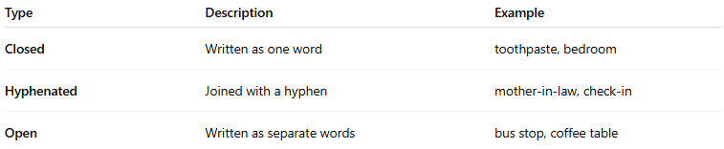
Type | Description | Example
Closed | Written as one word | toothpaste, bedroom
Hyphenated | Joined with a hyphen | mother-in-law, check-in
Open | Written as separate words | bus stop, coffee table

📚 Examples of Compound Nouns:
# Source: AI Source: Provided by: [Data Path: Persons Table -> ID Column: 1, Name_En Column: Motasem Essam] -> From: [Chatgpt (GPT-4-turbo)] on [7/26/2025]
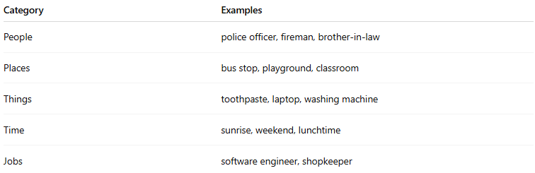
Category | Examples
People | police officer, fireman, brother-in-law
Places | bus stop, playground, classroom
Things | toothpaste, laptop, washing machine
Time | sunrise, weekend, lunchtime
Jobs | software engineer, shopkeeper

📝 Example Sentences:
# Source: AI Source: Provided by: [Data Path: Persons Table -> ID Column: 1, Name_En Column: Motasem Essam] -> From: [Chatgpt (GPT-4-turbo)] on [7/26/2025]
- I need to buy some toothpaste. (closed)
- She is my sister-in-law. (hyphenated)
- They waited at the bus stop. (open)

✅ Compound Noun = Word 1 + Word 2 = New Noun
# Source: AI Source: Provided by: [Data Path: Persons Table -> ID Column: 1, Name_En Column: Motasem Essam] -> From: [Chatgpt (GPT-4-turbo)] on [7/26/2025]
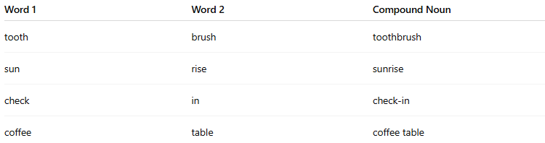
Word 1 | Word 2 | Compound Noun
tooth | brush | toothbrush
sun | rise | sunrise
check | in | check-in
coffee | table | coffee table

🔄 Related:
# Source: AI Source: Provided by: [Data Path: Persons Table -> ID Column: 1, Name_En Column: Motasem Essam] -> From: [Chatgpt (GPT-4-turbo)] on [7/26/2025]
- Compound noun = noun + noun or adj + noun (e.g., blackboard, swimming pool)
- Don’t confuse with compound words in general, which can be any part of speech

is Compound Noun is Compound word

✅ Yes — A Compound Noun is a Type of Compound Word.
# Source: AI Source: Provided by: [Data Path: Persons Table -> ID Column: 1, Name_En Column: Motasem Essam] -> From: [Chatgpt (GPT-4-turbo)] on [7/26/2025]
Let’s break it down clearly:

🔹 What is a Compound Word?
# Source: AI Source: Provided by: [Data Path: Persons Table -> ID Column: 1, Name_En Column: Motasem Essam] -> From: [Chatgpt (GPT-4-turbo)] on [7/26/2025]
A compound word is any word formed by joining two or more words to create a new word with a specific meaning.
Examples:
- toothbrush (noun)
- blue-green (adjective)
- babysit (verb)
👉 So, compound words can be nouns, verbs, adjectives, adverbs, etc.

🔹 What is a Compound Noun?
# Source: AI Source: Provided by: [Data Path: Persons Table -> ID Column: 1, Name_En Column: Motasem Essam] -> From: [Chatgpt (GPT-4-turbo)] on [7/26/2025]
A compound noun is a type of compound word that functions specifically as a noun — it names a person, place, thing, or idea.
Examples:
- toothbrush (thing)
- bus stop (place)
- mother-in-law (person)

🧠 Summary Table:
# Source: AI Source: Provided by: [Data Path: Persons Table -> ID Column: 1, Name_En Column: Motasem Essam] -> From: [Chatgpt (GPT-4-turbo)] on [7/26/2025]
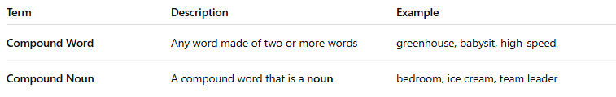
Term | Description | Example
Compound Word | Any word made of two or more words | greenhouse, babysit, high-speed
Compound Noun | A compound word that is a noun | bedroom, ice cream, team leader
✅ All compound nouns are compound words,
❌ but not all compound words are nouns.

✔️ Quick Example Breakdown:
# Source: AI Source: Provided by: [Data Path: Persons Table -> ID Column: 1, Name_En Column: Motasem Essam] -> From: [Chatgpt (GPT-4-turbo)] on [7/26/2025]
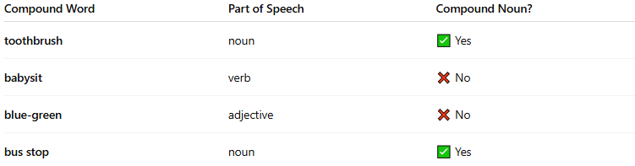
Compound Word | Part of Speech | Compound Noun?
toothbrush | noun | ✅ Yes
babysit | verb | ❌ No
blue-green | adjective | ❌ No
bus stop | noun | ✅ Yes

Let me know if you’d like to see the types of compound words by part of speech!

✅ Summary:
# Source: AI Source: Provided by: [Data Path: Persons Table -> ID Column: 1, Name_En Column: Motasem Essam] -> From: [Chatgpt (GPT-4-turbo)] on [7/26/2025]
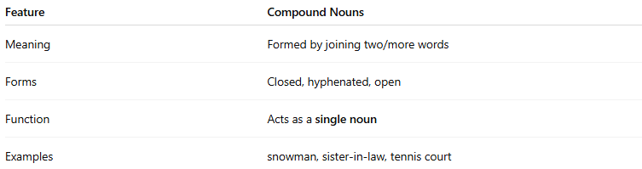
Feature | Compound Nouns
Meaning | Formed by joining two/more words
Forms | Closed, hyphenated, open
Function | Acts as a single noun
Examples | snowman, sister-in-law, tennis court

